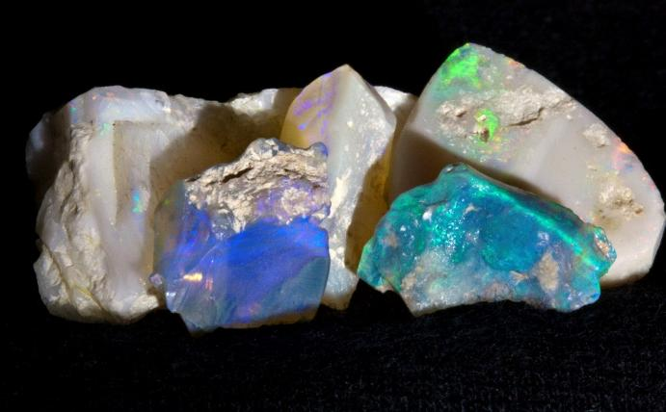
In this issue
March 2026

Maplewood
Rock and Gem Club
Lapidary Arts Classes 3
How to turn your hobby into a business 3
How to Clean and Prep Stones 3
Stone Carving Basics and Wet Angle Grinder 4
Teach us and learn 5
Moving Forward with Integrity 6
Meeting the Standard 6
Important: Board Vacancies 7
What Happens Next? 7
Calendar of Events 8
NW Crystal Sale 9
Common Opal 10
Free days 15
Rock lovers everywhere 17
Before you go 17
Rockhounding Hosts 18
Trips and shows 18
Maps for Rockhounds 21
About Us 22
Lapidary Shop 22
Connect with us 23
Our Board 23
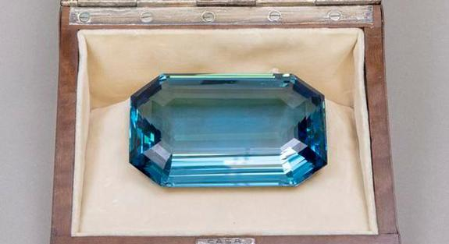
March 26

March meeting

Monday, February 16 at 7 pm
At our March meeting we will hear a presentation by Michael F. of the North Puget Sound Faceting Guild. He will talk about the lapidary art of faceting gemstones. Thanks to Don Wilcox for inviting Michael to speak.

Other meeting highlights are the Silent Auction, which is orchestrated by Paul Newby, and our Show and Tell where you may tell us about one or two of the specimens in your collection. Have you done faceting? If so, that would be something to bring. Otherwise, just bring a fascinating rock.

Lapidary class in March
On March 19th Don Wilcox is leading a class to help us understand how to turn a lapidary hobby into a business. Learn more about this class on page 2.

Banner Image
The banner image is a photo of the 1,298 carat Roosevelt aquamarine in its custom art deco gift box. The gem is part of the collection of the Franklin D. Roosevelt Presidential Library and Museum, and the photo is in the public domain.

Classes in Lapidary Arts

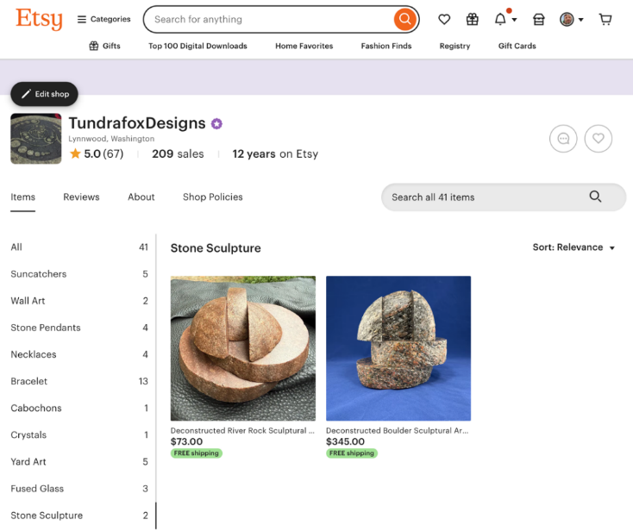
How to turn your hobby into a business

March 19 from 6:30 to 8 pm (tentative date)
This will be a high level discussion on how to sell items online, both on Etsy and standalone website. Topics will also include basics of state tax filing and payment, and payment/billing considerations.

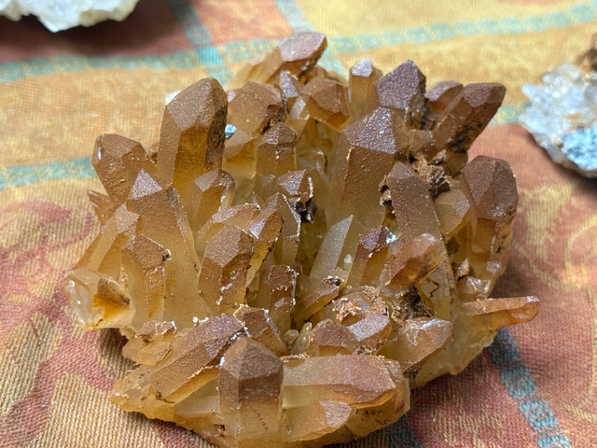
How to Clean and Prep Stones

May 21 (tentative)
from 6:30 to 8 pm
The discussion will focus on a handful of methods to clean quartz, epidote, pyrite, and other materials we find locally in the Pacific Northwest. There will be samples of before and after. The discussion will include chemicals needed and related safety.

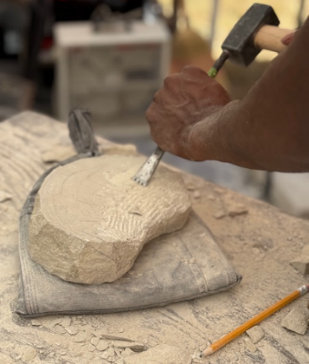
Stone Carving Basics and Wet Angle Grinder

June 25 (tentative)
from 6:30 to 8 pm
Ever wondered about carving stone? This discussion will show basic hand tools, power tools, stone, and safety gear. There will be a basic demo as weather and space allow.

Don Wilcox
Don has been a member of Maplewood Rock and Gem Club for over 18 years. He has served on the board including 2 terms as president. He has been creating art for over 25 years and is a member of the Northwest Stone Carving Association. He created Tundrafox Designs as his business where he makes and sells lapidary items, pushed glass, sculptures, and more. You can find Don and his work
at Etsy https://www.etsy.com/shop/TundrafoxDesigns?ref=shop_profile&listing_id=1657011904
And on the web https://tundrafoxdesigns.com/

Here are two of Don’s sculptures.
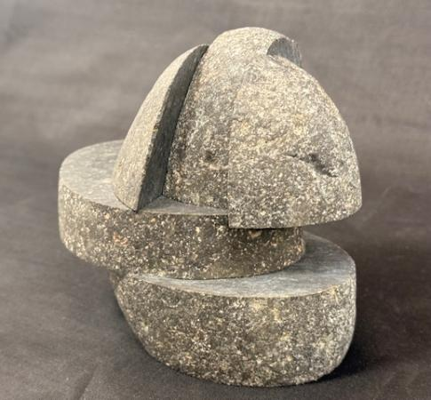
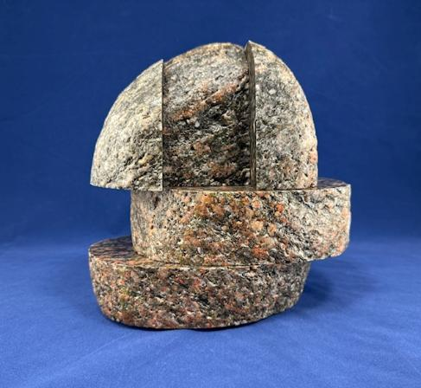


Teach us and learn

When you joined the club, did you look forward to learning from our knowledgeable members? Were you eager to work a raw stone into a gorgeous, finished piece? Were you curious about the seemingly impossible way that beautiful crystals form inside plain rocks? Have you wondered how to read the geography of a landscape?

While curiosity still compels you to learn, you likely hold knowledge that others would delight in knowing.

“In learning you will teach, and in teaching you will learn.”
~ Phil Collins

In Son of Man Phil Collins tells us that we learn and deepen our own understanding by teaching others.
Each month a member or guest shares their knowledge with our community during the General meetings and at the Juniors’ meetings. The topics are as varied as our members’ curiosities and expertise: for example,
- Geography
- mining claims in our area
- fossils
- terminology
- rock identification
- running a business of selling lapidary art

Please think about what you know and consider giving a little of your knowledge to our members during a monthly meeting. Then, at the other meetings, you can sit back and enjoy learning from others. Talk with a Board member to learn more.

Moving Forward with Integrity: Announcing Nominees

Following our recent commitment to return to the foundational procedures of our By-Laws, the MRGC Nominating Committee has been hard at work. As shared in the January newsletter, transparency and "doing things properly" are our top priorities as we reset our 2026 Board elections.
Today, we are pleased to take the first official step in that reset by introducing our nominees for the two Member-at-Large positions and the President role.

Meeting the Standard
Per our club’s governing rules, all new nominations must be vetted and published in the newsletter one month prior to a vote. This "Advance Notice" ensures that you, the members, have ample time to get to know those who wish to represent you.
After a thoughtful review process, the Nominating Committee is proud to present the following candidates for the 2026 Board:
President:  Angela Vitense | Angela recently served as our 2025 Interim President and brings over 20 years of corporate expertise in Project Management and Store Development to the table. A member for two years, she has already made a significant impact by leading the Container Clean Out project and serving on the Ways & Means committee. Angela’s blend of professional seniority and her willingness to assist with everything from annual shows to daily operations ensures a strong, organized foundation for our 2026 Board.
Member at Large Nominee:  Nathan O’Brien | Nathan’s journey with MRGC began as a teenager, and today he stands as one of our most experienced leaders. Having served on the Board for over [XX] years and as a Shop Steward for [XX], Nathan’s "boots on the ground" perspective is invaluable. He is an avid rockhounder whose vast knowledge of the trade is matched only by his willingness to help—he is a volunteer who truly takes on anything asked of him. Nathan’s deep roots and passion for our future make him an ideal candidate to represent our members.
Member at Large Nominee:  Craig Kosovich | A long-time member and a pillar of our operational team, Craig has served as our Rentals Lead for over three years, managing one of the club's most active touchpoints with the public. Beyond his dedication to the Club, Craig brings a sophisticated nonprofit background to the table. This experience gives him a unique understanding of how organizations like ours thrive—balancing mission-driven goals with fiscal responsibility. His steady hand and professional insight make him a perfect fit to represent the membership as a Member-at-Large.

Important: Board Vacancies
While we are excited to fill our Member-at-Large and President seats, our leadership team is not yet complete. To ensure the long-term stability of MRGC, we are still actively seeking dedicated individuals for the following critical roles:
- Vice President: A key leadership position that supports the President and oversees club programming and special initiatives.
- Secretary: The "memory" of our club. This individual is responsible for maintaining accurate records of our meetings, managing correspondence, and ensuring our history is preserved.
Note: Because these positions remain open, we invite any member interested in these leadership roles to step forward. Please reach out to our Nomination Committee or any existing Board members.

What Happens Next?
In accordance with our "Notification Rule," the names of our nominees are being presented to you now to fulfill our requirement for advance publication.
- The Vote: The formal election for the three positions will take place at our next General Meeting.
- Discussion: We encourage you to bring any questions regarding these nominations—or your interest in the Vice President or Secretary roles—to the March 16 General Meeting.

Calendar of Events

Here are some important dates for your calendar. Parties and social time are such valuable ways we get to know each other that we dedicate two meetings a year to them. In August we have a summer celebration and in December we have a holiday party. All our other meetings are on the third Monday at 7 pm.

Event | Date | What’s happening
How to Turn Your Hobby into a Business | March 19 (tentative) | Class
How to Clean and Prep Stones | May 21 (tentative) | Class
Stone Carving Basics and Wet Angle Grinder | June (tentative) | Class
Summer show | August 15 – 16 (tentative) | Show
Summer Celebration | August 17  usually at 6 pm | Summer celebration and August meeting
Holiday show | December, first or second weekend | Show
Holiday Party | December 14 at  6 pm | Potluck dinner and party instead of the December meeting


Feeling a bit unwell?
There are a lot of colds and flus going around right now.
If you are feeling a bit unwell, please stay home from
the meeting, classes, and from the Lapidary Shop.
We are a community, and we help one another by
stopping viruses from infecting our friends.

NW Crystal Sale

Saturday April 18th
10 am to 6 pm
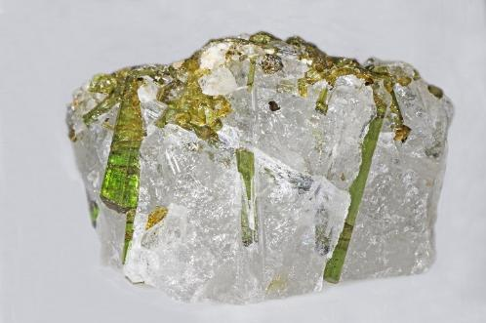
Joel Clark is renting our building on the 18th to host the Northwest Crystal Sale. He has 10 to 12 vendors lined up who will sell specimens, geodes, and slabs they have collected in Washington and beyond. The wide variety of rocks for sale will include
- Agates
- Calcite crystals
- Quartz of all varieties
- Barite crystals
- Fluorite crystals
- Scheelite crystals
- Dolomite crystals
- Magnesite crystals
- Azurite
- Malachite
“Tourmaline in quartz” by Judy Gallagher, CC BY 2.0
- Aragonite stalactites
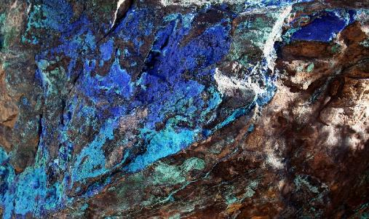
- GTourmaline crystals or sprays
Malachite
- Feldspar crystals
- Beryl crystals
- White river geodes
- Zektzerite crystals
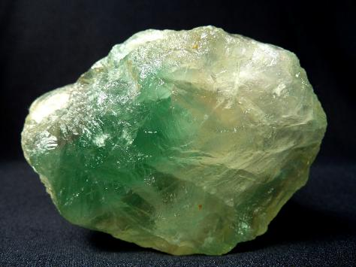

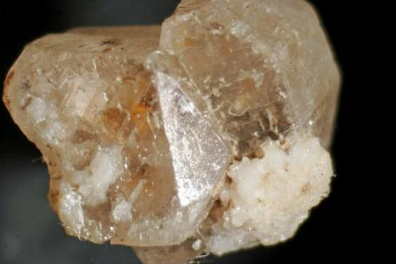

Fluorite
“Zektzerite: Twinned Micro-crystals”;
by Jake Slagle; license CC BY-NA 2.0; collected at Washington Pass,
Okanogan Co.,Washington

Colorful “Common” Opal in the Pacific Northwest

By Jim Miller
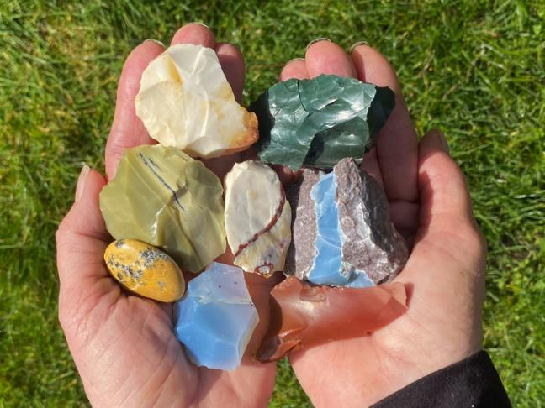
The word “opal” typically brings to mind spectacular gemstones with beautiful plays of multicolored fire. If opal does not display a play-of-color, it is referred to as “common” opal or “potch” opal. Despite these unflattering names, common opal is a fascinating stone with tremendous diversity of color, clarity, pattern, and quality. Handfuls of colorful opal varieties are shown here.

Opal consists of amorphous (non-crystallized) silica combined with 3 to 15 percent water, as well as inclusions of various impurities and micro-crystals. Its structure is more like a gel than crystallized rock. Opal is distinguished by its conchoidal (smooth, curving) fracture surfaces that typically have glossy or satin reflectance. In my experience, higher glossiness usually is associated with a higher water content in the stone. Opal with a high water content is often subject to “crazing” if it is dried or exposed to excessive heat or cold. The hardness of common opal ranges from 5.0 to 6.0 on the Mohs hardness scale. Its relative softness means that it can be scratched by harder minerals like quartz. Common opal is quite brittle and can be fractured easily with relatively little impact force. Harder pieces can take an exceptional polish.
Opal is a secondary material. That means it forms after the original host rock was deposited. Three conditions must be met to produce this interesting stone: 1) there must be a source of soluble silica, 2) water must be available to carry the soluble silica through the rock mass, and 3) physical conditions within the rock mass must be suitable for precipitation of the silica. Cavities and open seams in volcanic rock are favored sites for the accumulation of common opal.
This story focuses on three different examples of gorgeous common opal from the Pacific Northwest. While these opals are included in the category of “common” opal, they definitely are not common!

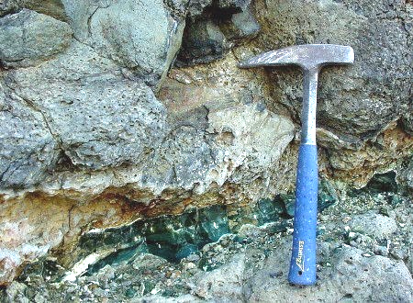
The first example opal for this story is interesting “Evergreen Opal” from a basalt quarry the vicinity of Walla Walla, Washington. The photo below shows a seam of this dark green opal in its hosts rock of basalt.

This unique green opal is quite stable and takes a great polish. Two tumbled pieces and an arrowhead I made out of this distinctive stone are shown below.
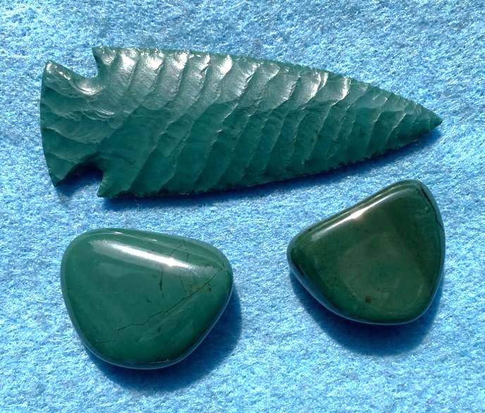
Unfortunately, expansion of the basalt quarry that contains this green opal has removed essentially all of this colorful seam.

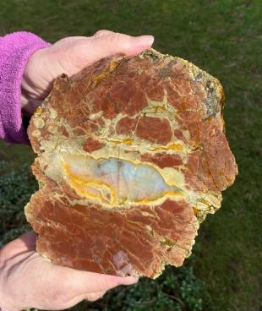
The second variety of common opal for this story is highly translucent “hyalite” opal. This amazing opal is found in the center of some thundereggs from Opal Butte in northeastern Oregon. The light-colored center of the thunderegg slice in the photo at the left is a small section of hyalite opal.

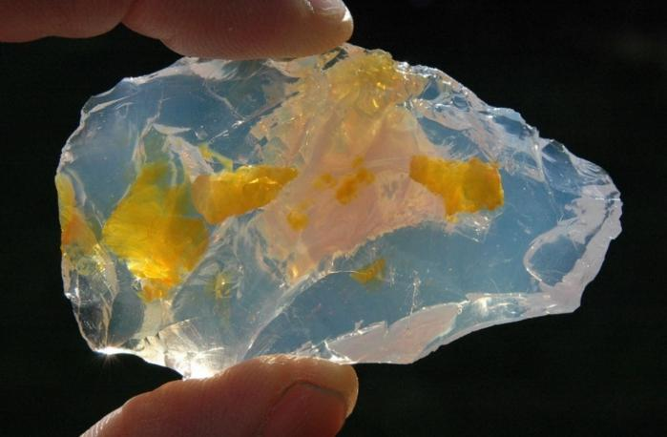
A few years ago I chatted with a man at a rock show who was showing off a flawless, fist-sized piece of polished hyalite opal; he was asking several thousand dollars for the piece. A beautiful example of Opal Butte hyalite opal is shown at the right, along with a gorgeous arrowhead that I made out of this special stone.
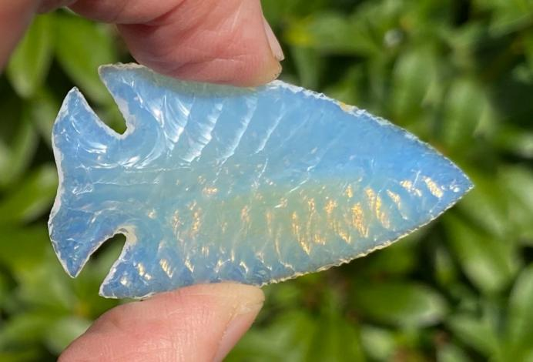

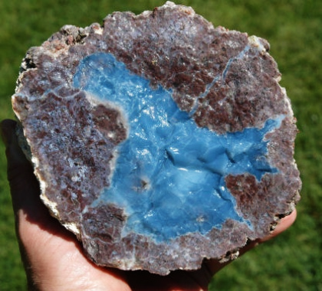
The third variety of special opal for this story also occurs in the center of thundereggs. This is “Owyhee Blue Opal” from the Oregon/Idaho border area. As shown here, this amazing blue opal occurs in the center of large thundereggs that are mined commercially by Silver Streams Northwest. Cabs made out of this spectacular opal are highly prized.
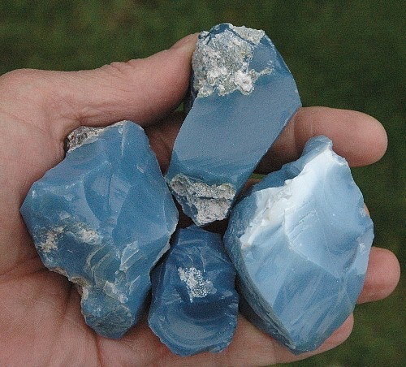
Some rough samples of this stone and three arrowheads I made from it are shown below.

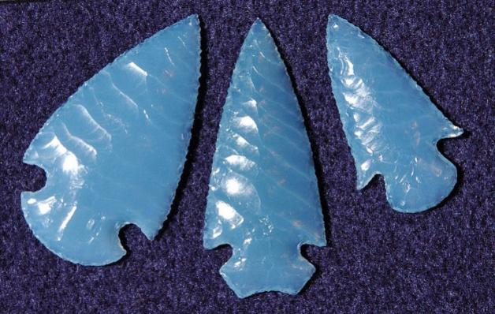
While not all common opal is as spectacular as the trio described in this story, numerous other examples of colorful common opal exist in the Pacific Northwest. Some of the other colors I’ve seen include white, red, pink, orange, brown and yellow. Colorful common opal makes eye-catching displays for rock collections, and cabs made from the higher quality opal can be incredible. So, if you hear someone say a piece of stone “is just common opal,” don’t dismiss it. You may find a very attractive addition to your rock collection!

Jim Miller
Jim Miller is a long-time member of Maplewood Rock & Gem Club. He is a retired geologist and holds a Bachelor of Science degree in geological engineering, as well as a Master of Science degree in environmental geology. Jim has loved rocks, fossils, crystals and the natural world since grade school. He enjoys rock tumbling and is an accomplished flintknapper. In 2006 Jim wrote and published a CD book on the types of stone used for knapping arrowheads and stone knives. He enjoys technical writing and has had several of his articles published in Rock & Gem magazine.

Rock Candy
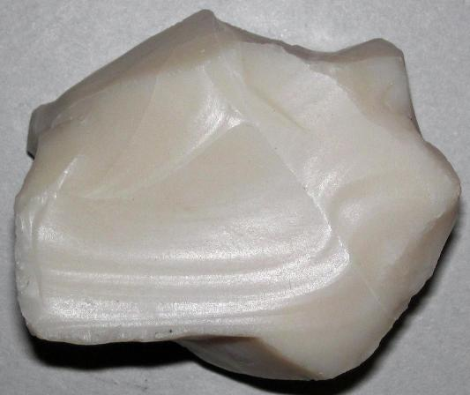
Common opal, like all opal, is a mineraloid, because it does not have a crystalline structure, but is instead made up of tiny spheres (colloids) which can be seen through a scanning electron microscope. Common opal has a waxy gloss and a conchoidal fracture. This specimen was found in Nevada and photographed by James St. John. The photo is published here under the Creative Commons license CC BY 2.0.

Who doesn’t like free?


In 2026 Washington public lands agencies have chosen the following days when you don’t need a Discover Pass to park at
- state parks
- Washington State Department of Natural Resouces land
- Washington Department of Fish and Wildlife land

A Discover Pass costs $45 for a year of parking on state land listed above. The pass covers two vehicles.

The Discover Pass funds significantly help the state agencies provide
- recreation opportunities
- conservation of forests and seashores
- clean bathrooms
- trail maintenance

The free days in 2026 are
Monday, March 9 – Billy Frank Jr.’s Birthday
Thursday, March 19 – State Parks 113th Birthday
Wednesday, April 22 – Earth Day
Saturday – Sunday, June 6-7 – Free Fishing Weekend
Friday, June 19 – Juneteenth
Sunday, Aug. 9 – Smokey Bear’s Birthday
Saturday, Sept. 26 – National Public Lands Day
Saturday, Oct. 10 – World Mental Health Day
Wednesday, Nov. 11 – Veterans Day

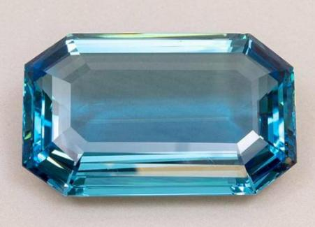
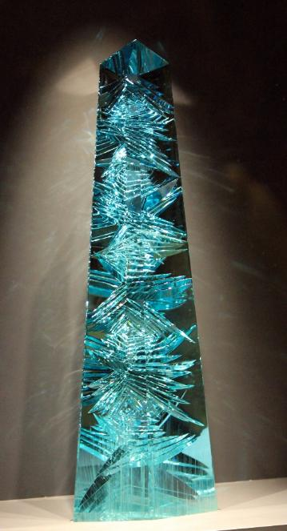

Happy Birthday

To everyone born in March!

You have two birthstones, aquamarine and bloodstone.

Brazilian President Getúlio Vargas gave Eleanor Roosevelt the largest cut aquamarine in the world (1,298-carat) when she and her husband visited in 1936. As a cut gem, it measures 9.5cm wide x 5.7cm deep x 2.9cm high, but the raw stone weighed 6,500 carats (2.86 pounds)! It was mined in the Brazilian state of Minas Gerais and sent to Amsterdam where cutter Gustav Reitbauer created two cut gems — the one given
to the Eleanor and a smaller one which was sold
to the Maharaja of Kapurthala in India.

Roosevelt aquamarine; public domain
Now, the Roosevelt aquamarine is only the
second largest cut aquamarine. The largest is the
Dom Pedro, a 10,363 carat gem cut into a 14”
obelisk with crisscrossing channels cut into it to
reflect light. The Dom Pedro was cut by Bernd
Munsteiner in Germany.
Photo by James H.; License CC BY-SA 2.0

Rock lovers everywhere

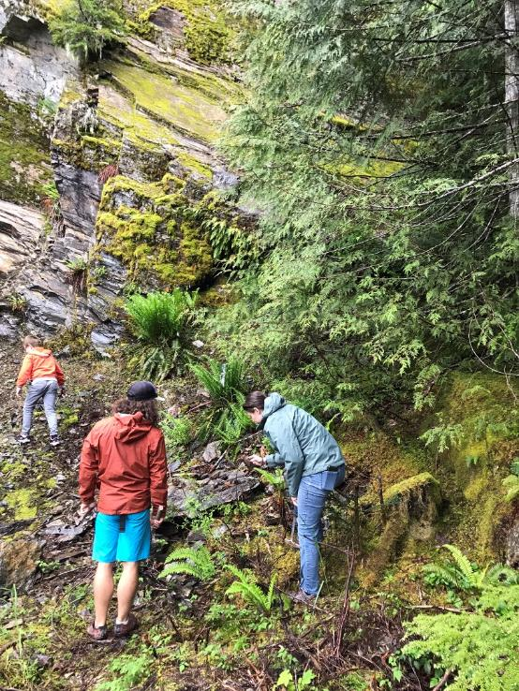
Before you go rockhounding
Rockhounding is fun to do with a group. Join one of the trips listed below and meet other local rockhounders. If you plan to go, please contact the host a week or so ahead to let them know you are coming and to find out if anything has changed.

As you get ready for the trip, we recommend that you go through this checklist:
- Contact the host a week before the trip.
- Plan your driving time so you arrive 30 minutes before the meeting time.
- If needed for parking, get a Discover Pass or America the Beautiful pass, as required.
- Collect your tools and containers for the rocks: https://mineralcouncil.wordpress.com/photos-of-collecting-tools/
- Prepare a first aid kit.
- Plan appropriate clothes, boots, gloves, snacks, and water.
- Gas up your vehicle.
- Review the Rockhound Code of Ethics. It’s important to follow these so that the lands remain open for rockhounding. https://mineralcouncil.wordpress.com/rockhound-code-of-ethics/

Rockhounding Hosts
Here is the contact information for hosts of the rockhounding trips:

Maplewood Club | Don Wilcox | wilcox.don@comcast.net
Marysville Club | Nique Wicks | nwhoppyfrog41@gmail.com  (509) 670-0630
Pow-Wow | Larry Vess | vessel3755@gmail.com  (253) 473-3908
Puyallup Club | Paul Haak | pvhaak@gmail.com  (253) 312-1743
Washington State Mineral Council | Ed Lehman  Nique Wicks (contact information is above) | wsmced2@outlook.com  (425) 334-6282
NW Federation of Mineralogical Societies | Doug True | dtruefossils12@yahoo.com  (406) 670-0506

Trips and shows

Date | Host and Location | Details
March 22 | Marysville  Skykomish | Search for picture jasper.  Bring a rock hammer, wading boots.
April 18 – 19 | Pow-Wow  Saddle Mountain | Search for petrified wood.  Bring a shovel, small pick, hammer (surface collection).
May 9 | Marysville  Finney Creek | Search for listwanite.  Bring digging tools, hard rock chisel, pry bar, sledgehammer.
May 21 – 25 | NW Federation  Blue Forest, Wyoming | To be announced
May 23 – 24 | Marysville  Kettle Falls, Wild Turkey Mine | Search for fossils and noble serpentine.  Bring a rock hammer and tools for hard rock or surface collection. Fee.
June 13 | Marysville  Saddle Mountain, Diatom Pit | Search for petrified wood and common opal.  Bring a shovel, small pick, rock hammer, buckets with lids (dust).
June 25 – 28 | NW Federation  Tee Pee Canyon Agate, South Dakota | To be announced
July 18 – 19 | Marysville  Lake Wenatchee | Search for garnet and talc.  Bring a shovel screen, container for garnets, hand saw.
Aug. | Maplewood Summer Show | To be announced
Aug. 15 – 16 | Puyallip  Greenwater | Search for agate, jasper, opal  Bring digging tools, chisel, small pry bar, rock hammer.
Sept. 12 – 13 | Pow-Wow  Red Top | Search for agate, jasper, geodes.  Bring digging tools, chisel, small pry bar, rock hammer.
Sept. 19 | Puyallip  Little Naches | Search for lily pad jasper, fossils, thunder eggs.  Bring digging tools, hard rock chisels, pry bar, 3# hammer, rock hammer.
Oct. 11 | Marysville  Walt Bailey | Search for rainbow chert.  Bring hard rock chisels, rock hammers, pry bars.
Nov. 7 | Marysville  Blanchard Hill | Search for Stilpnomelane (dalmation stone).  Bring hard rock flat chisels, hammers, pry bars.
Dec.  5 – 6th | Maplewood Rock and Gem Club | Holiday Show

Grit and oil for sale
The Shop Stewards have grit. When the shop is open you can buy grit or oil. Please email them a day ahead of when you will stop by: shop@maplewoodrockclub.com
Each grit package is $4, and this is what they sell:
1 lb of 60/90 ¾ lb of pre-polish
1 lb of 120/220 ½ lb of polish

Gallon of oil for $20 (Bring your own container.)

Washington State Mineral Council
Our club, along with many other rock and gem clubs in the state, is a member of the Washington State Mineral Council. This organization helps us by
- advocating for access to public lands
- advocating for beneficial land use policies
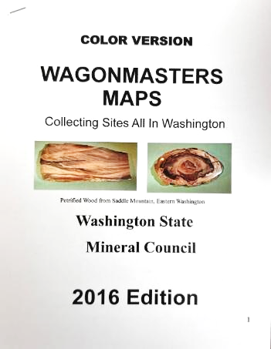
- compiling and sharing maps and other information
- publicizing shows and field trips so members learn about and can participate in events at other clubs

Read their latest Newsletter.

Maps for Rockhounds
The Washington State Mineral Council has put together a 62-page booklet with maps for finding rock hounding sites. You can buy a copy for only $20 at the meeting.

Seattle Regional Gem and Mineral Shows Committee
Our club is a member of a Seattle area organization of rock clubs. Together we share wooden display cases that we use at our shows. These cases are stored in the new shed behind our building. The other member clubs are the North Seattle Lapidary Gem and Mineral Club and the West Seattle Rock Club.

Northwest Federation of Mineralogical Societies
Our club is a member of the Northwest Federation of Mineralogical Societies: http://Northwestfederation.org. We email their newsletter to our members each month.

About Us

Shop Stewards
Rich Osborne
Bruce Samuels
Nathan O’Brien
Dirk Sierag
Scott Higson

Shop@maplewoodrockclub.com

Lapidary Shop
Our lapidary shop is reserved for members who have paid their dues. Inside are five slab saws, three CabKing™ machines for polishing cabochons, and two trim saws.

Sign up for shop time
All shop users must sign up for a time slot at least a day before the session. On their first visit, new shop users will be trained on shop procedures and safety before being able to use any equipment.

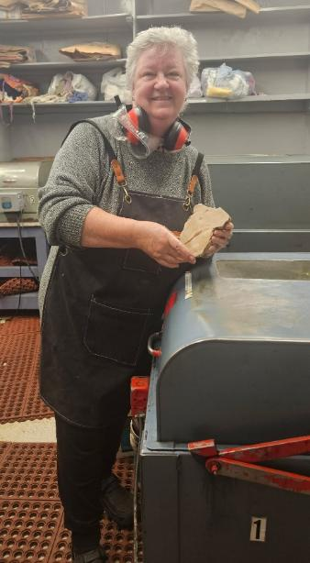
You can sign up for shop time online. The system will send you a confirmation email which you should save until after your session. You will need the email if you need to cancel your reservation. Each Thursday and the 1st and 3rd Wednesdays we have two shop sessions available:
- Session 1: from 3:00 to 5:30 pm
- Session 2: from 5:30 to 8:00 pm

How to cancel
If you sign up for shop time online and later realize you won’t be able to make it, you need to cancel your reservation no later than two days before the session. So, if you are cancelling a Thursday time, you need to cancel by Tuesday at midnight. This enables someone else to sign up. If you do not cancel, you will be charged for the session. To cancel, click the link in the confirmation email you received.

What to bring
You need to bring $10 (cash or check) to pay for the session. Additionally, please bring these:
- Eye protection
- Hearing protectors

Before you leave the shop
The shop stewards are volunteers who generously give 6 hours a week to enable us to use the tools. Before you leave a tool station, please wipe it down and leave it in the same condition as you found it. If you discover a problem with a saw or tool, please let the Shop Steward know.

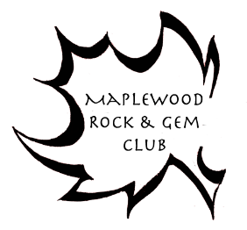
Connect with us
Website: http://www.maplewoodrockclub.com/
Facebook page: Maplewood Rock & Gem Club
Facebook group for members: MRGC Sales and Trades
Email us: info@maplewoodrockclub.com

Address: 8802 196th St SW, Edmonds, Washington 98026

Our Board
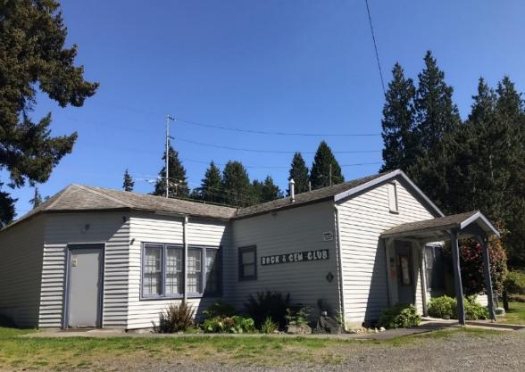
Our club is run entirely by volunteers; and we are grateful for the time, energy, and expertise they give to our community.

President: open
Vice President: open
Treasurer: Lisa Rammell
Secretary: open
Past President: Angela Vitense
Members at large: Paul Newby, Mark Tomas, and two openings.

Image licenses
We use abbreviations in the license attributions. Here are the definitions.
CC: Creative Commons license
BY: attribute the author, link to the license, and indicate if changes were made.
SA: share alike - If you publish the image, you must use the same license.
ND: no derivatives - You may not alter the image.
NC: non-commercial use - You may not use the image for commercial use.
3.0 or other number: version of the license
News to share?
Did you go rockhounding? Have you acquired a beautiful new specimen? Contact Nancy Samuels, the Editor at MRGC@nancysamuels.com.
This issue
Maplewood Rock and Gem Club News

Volume 03
Publication year: 75

