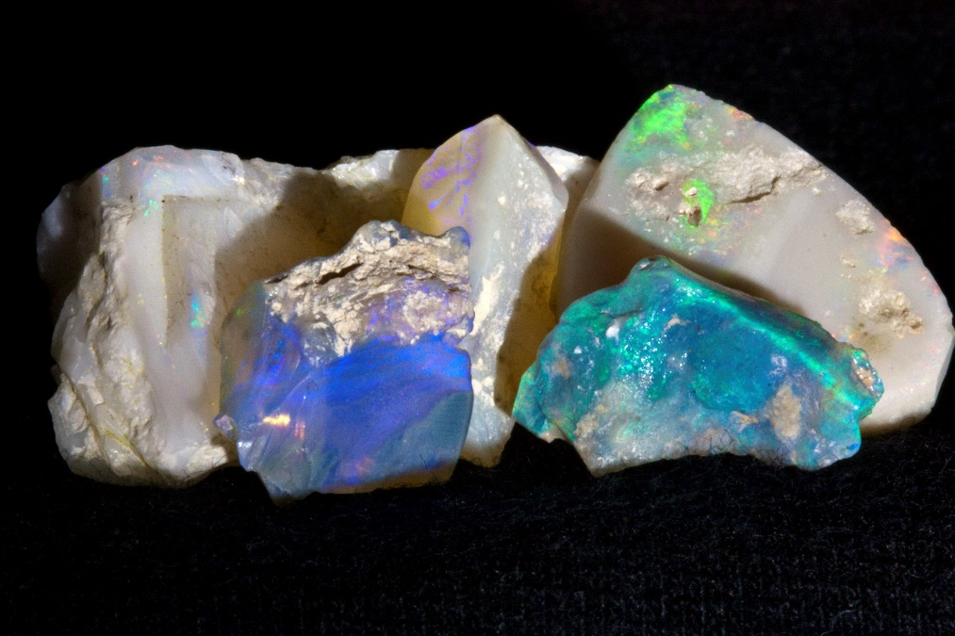
In this issue
February 2026

Maplewood
Rock and Gem Club
Volunteers ─ Thanks! 2
Classes: Lapidary Arts 3
How to turn your hobby into a business 3
How to Clean and Prep Stones 3
Stone Carving Basics and Wet Angle Grinder 4
Don Wilcox 4
Calendar of Events 5
Ammonite Collecting by Helicopter in Alaska 6
Jim Miller 12
Who doesn’t like free? 13
Rock lovers everywhere 15
Before rockhounding 15
Rockhounding Hosts 16
Trips and shows 16
Washington State Mineral Council 19
Maps for Rockhounds 19
About Us 20
Shop Stewards 20
Lapidary Shop 20
Connect with us 21
Our Board 21
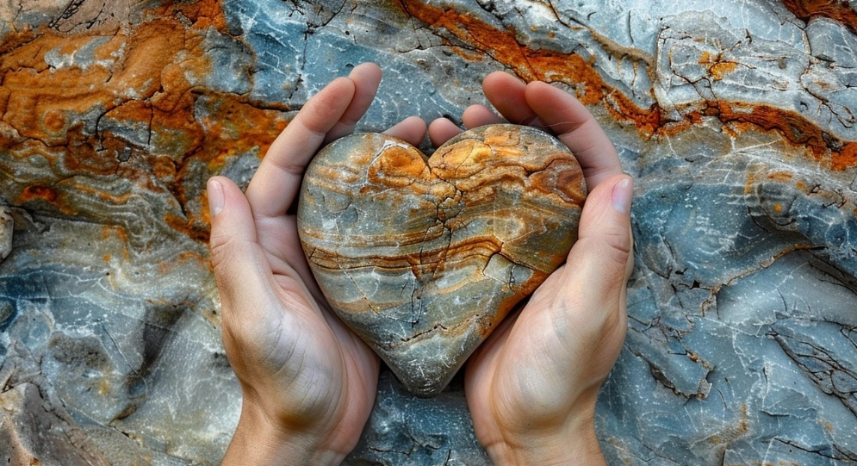
February 26

February meeting

Monday, February 16 at 7 pm
Our February meeting will have a Silent Auction organized by Paul Newby. Come ready to bid on interesting specimens for your collection.

A few members haven’t renewed their memberships yet; if you are one of them, connect with Bruce Samuels at the meeting, and he can help you renew. If you joined in the past few months and haven’t picked up your name badge, that’s also something you should talk with Bruce about. He has some badges waiting for people.

Lapidary class in March
Don Wilcox is leading a class next month to help us understand how to turn your lapidary hobby into a business. Learn more about this class on page 3.

Banner Image
The banner image is a photo of a heart carved out of a beautiful foliated rock. The photo is by Djovan and is published here under the Pixabay license.

Volunteers ─ Thank you!



Thank you to all the generous people who are rowing together for our Maplewood Rock Club team.
Spring show is cancelled

The Board has decided to cancel our April show this year while we focus on filling the open Board positions and important leadership roles, including the Shows Manager. This gives us time to plan a spectacular August show.

With no paid staff our club can only provide shows, classes, rentals, Rock of the Month presentations, and other member benefits if generous people donate their time and talent to those roles. Please ask a Board member how you can help in a big way or with a small limited commitment, if that works better for you.

John Wolfe has stepped into the Rentals Coordinator position; we are fortunate to have his leadership in this important job.

Michele McGraw has volunteered to take minutes at meetings through February.

More than a dozen other club volunteers, like Merilee Krebs who is our Communications Coordinator, and Paul Newby who runs our Silent Auction, are keeping this place running so we can all benefit by being members of this club.

To all our volunteers, “Thank you!”

Classes in Lapidary Arts

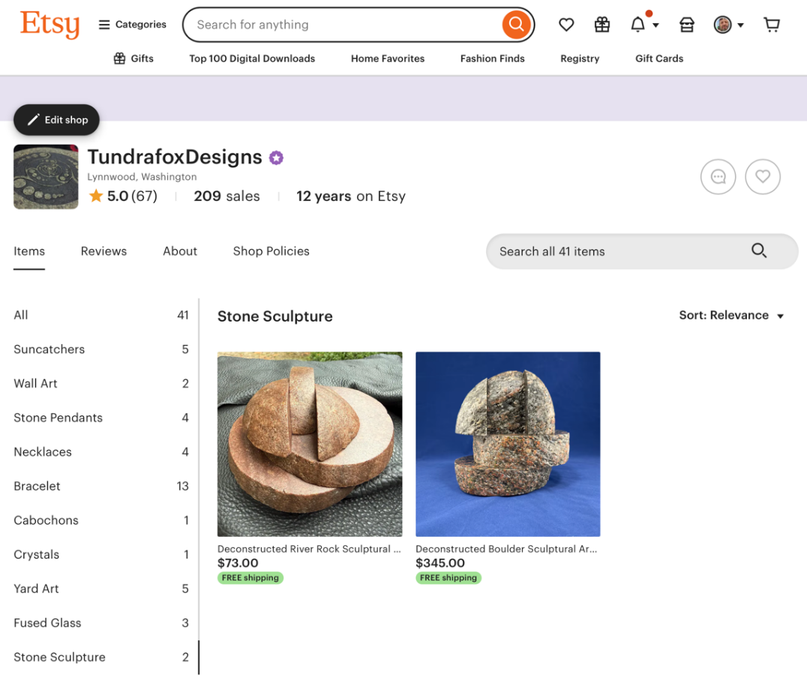
How to turn your hobby into a business

March 19 from 6:30 to 8 pm (tentative date)
This will be a high level discussion on how to sell items on online, both Etsy and standalone website. Topics will also include basics of state tax filing and payment, and payment/billing considerations.

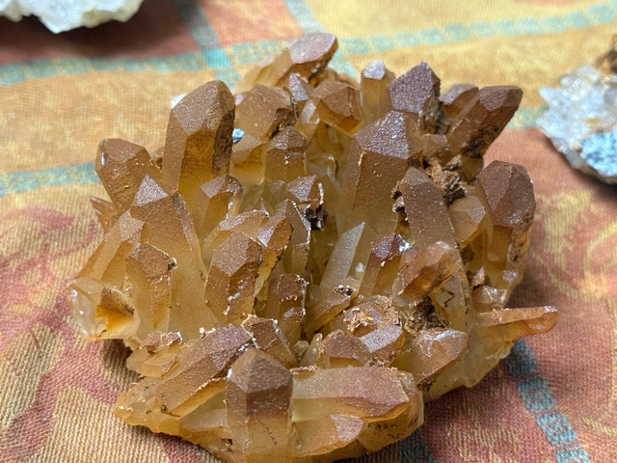
How to Clean and Prep Stones

May 21 (tentative)
from 6:30 to 8 pm
The discussion will focus on a handful of methods to clean quartz, epidote, pyrite, and other materials we find locally in the Pacific Northwest. There will be samples of before and after. The discussion will include chemicals needed and related safety.

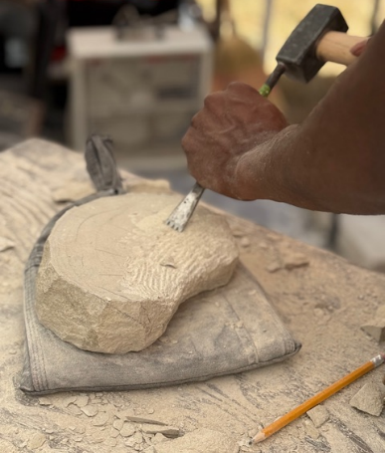
Stone Carving Basics and Wet Angle Grinder

June 25 (tentative)
from 6:30 to 8 pm
Ever wondered about carving stone? This discussion will show basic hand tools, power tools, stone, and safety gear. There will be a basic demo as weather and space allow.

Don Wilcox
Don has been a member of Maplewood Rock and Gem Club for over 18 years. He has served on the board including 2 terms as president. He has been creating art for over 25 years and is a member of the Northwest Stone Carving Association. He created Tundrafox Designs as his business where he makes and sells lapidary items, pushed glass, sculptures, and more. You can find Don and his work
at Etsy https://www.etsy.com/shop/TundrafoxDesigns?ref=shop_profile&listing_id=1657011904
And on the web https://tundrafoxdesigns.com/



Feeling a bit unwell?
There are a lot of colds and flus going around right now.
If you are feeling a bit unwell, please stay home from
the meeting, classes, and from the Lapidary Shop.
We are a community, and we help one another by
stopping viruses from infecting our friends.

Calendar of Events

Here are some important dates for your calendar. Parties and social time are such valuable ways we get to know each other that we dedicate two meetings a year to them. In August we have a summer celebration and in December we have a holiday party. All our other meetings are on the third Monday at 7 pm.

Event | Date | What’s happening
How to Turn Your Hobby into a Business | March 19 (tentative) | Class
How to Clean and Prep Stones | May 21 (tentative) | Class
Stone Carving Basics and Wet Angle Grinder | June (tentative) | Class
Summer show | August 15 – 16 (tentative) | Show
Summer Celebration | August 17  usually at 6 pm | Summer celebration and August meeting
Holiday show | December, first or second weekend | Show
Holiday Party | December 14 at  6 pm | Potluck dinner and party instead of the December meeting

Ammonite Collecting by Helicopter in Alaska

By Jim Miller

Back in 2005 I was on a business trip to Anchorage, Alaska when I was offered the chance to participate in a very unique fossil hunting adventure. This opportunity-of-a-lifetime was centered around a chartered helicopter trip to a remote section of the Chugach Mountains northeast of Anchorage. The goal: collecting ammonite fossils on exposed mountain slopes. Oh yeah! How could I NOT participate?

About a dozen friends, fellow employees, and clients jumped at the chance for this excursion. There are no roads to the destination in question, so a helicopter was our mode of transportation. We gathered at a private heliport to depart on an exciting flight to the fossil location. Because of the size of the group, two trips to and from the collecting site were needed. The photo below shows the helicopter taking off from the heliport.

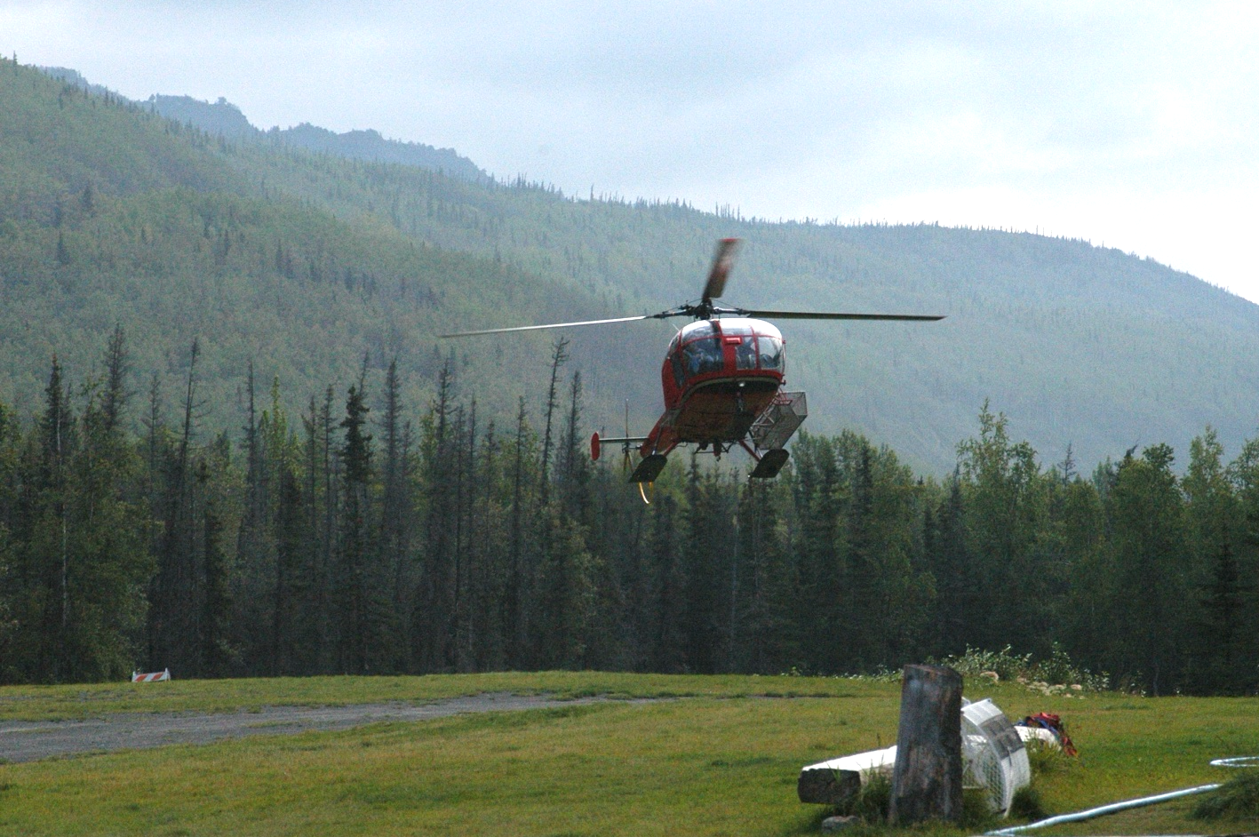

The helicopter flight of about 15 minutes took us well above tree line with spectacular views of the rugged mountains in the Chugach Range. As we approached the fossil location, we were rewarded with a great view of the opposite side of the valley, as shown below.

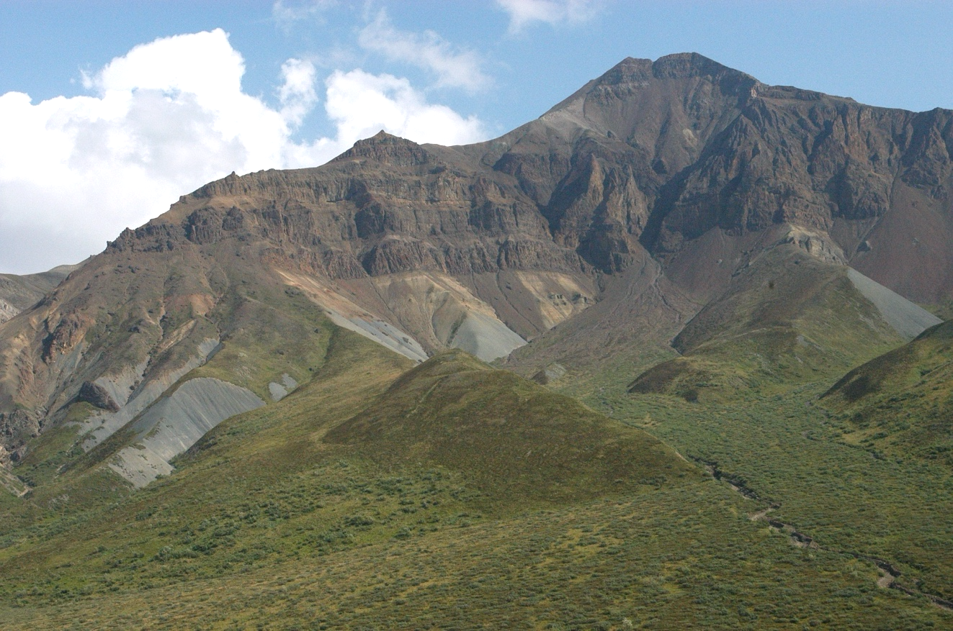

Several different geologic units are visible in the image above. Of particular interest are the exposures of gray shale near the base of the slope. The shale formation is exposed on both sides of the valley and contains the fossils we were seeking. The shale was originally deposited in a shallow sea about 80 million years ago.

Landing a helicopter in mountainous terrain can be a challenge. The pilot found a suitable location on a ridge near the gray shale formation. The landing site is shown on the next page.

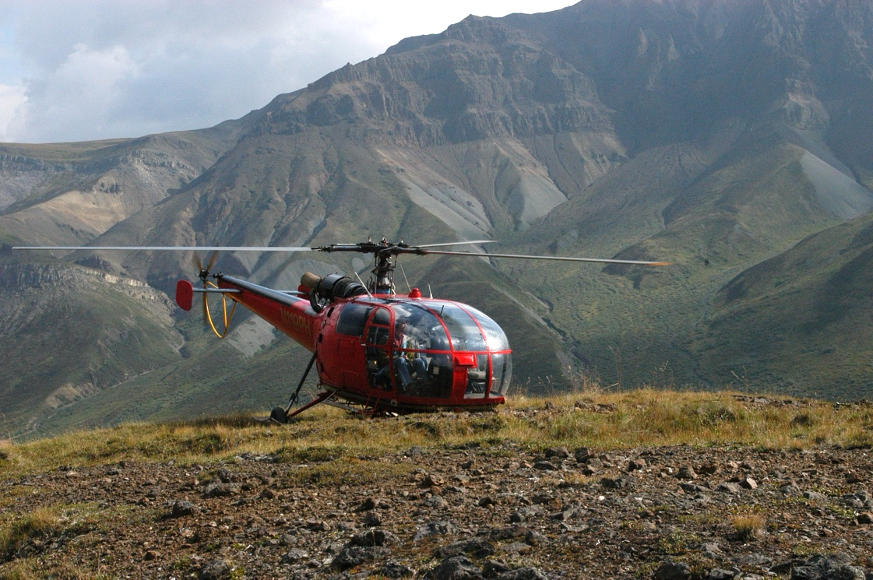

Once on the ground we dispersed to search for ammonite fossils near the landing site. The steep exposures of gray shale contained fairly frequent fossils, but getting them out of the dense shale was a challenge. All of the ammonites we found at this location were relatively large and required digging to extract them from their shale tomb, as shown below.

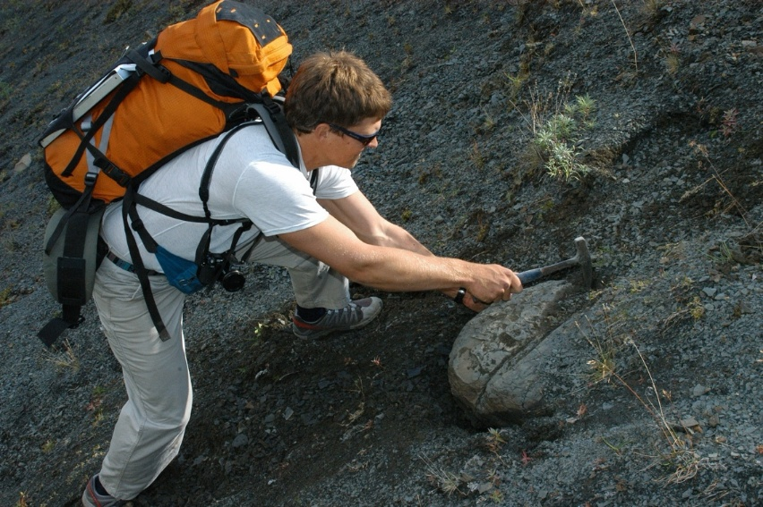
The steep shale slope was difficult to traverse with little in the way of footholds. The slope got steeper at its base, and involved a jump of about six feet to get to the tiny creek at the base of the slope. The slope was scary and I wouldn’t choose to descend it again!

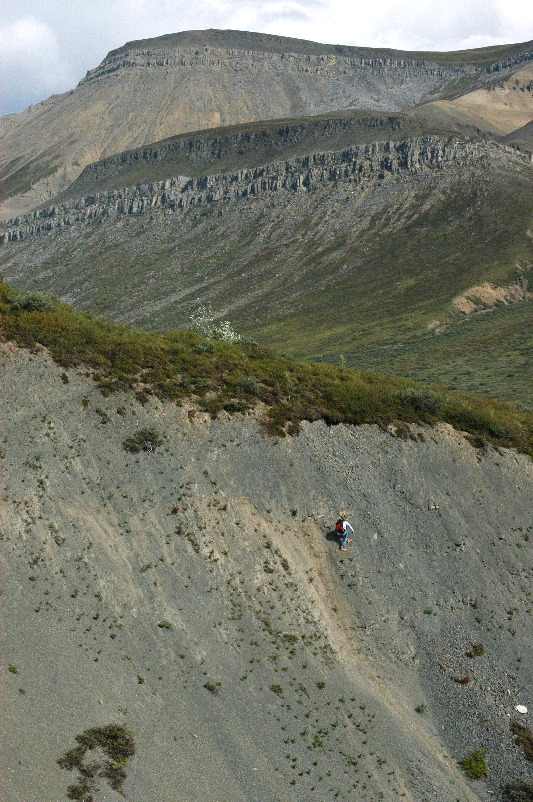
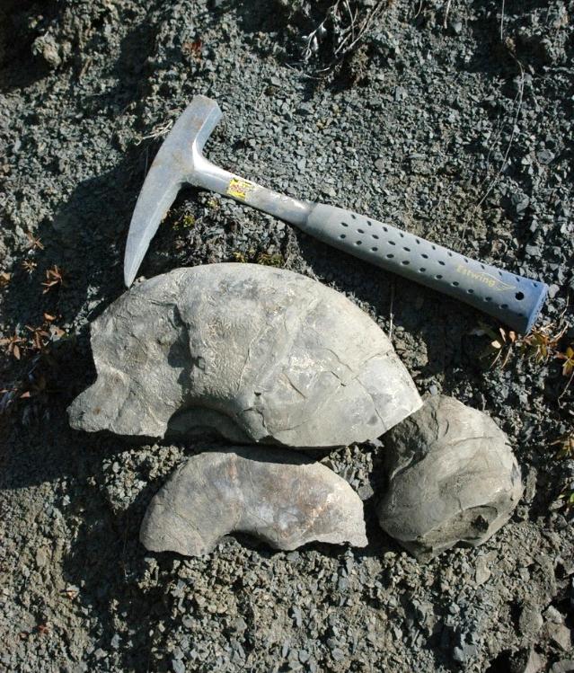
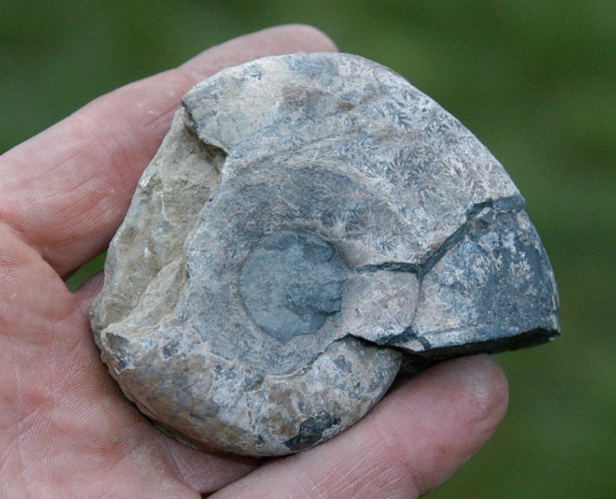
Besides the effort required to find and remove the fossils, they were heavy! It was tiring work to haul them to the helicopter landing site. But despite the challenges, all participants found some interesting fossils to take home. I collected some large ammonite pieces and a nearly complete hand-sized specimen, as shown here.

Although I didn’t score exceptional fossils, I did find a very interesting piece, as shown here. This is an external mold of the central spiral of these extinct coiled creatures.

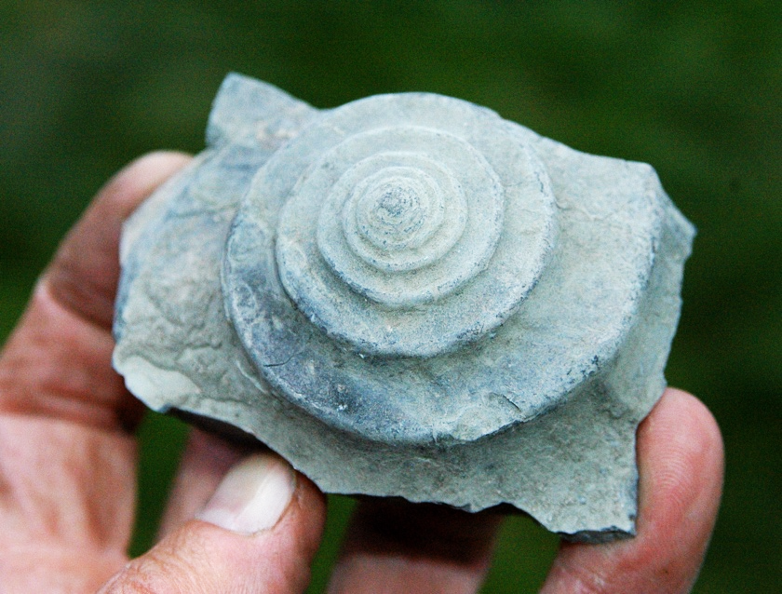

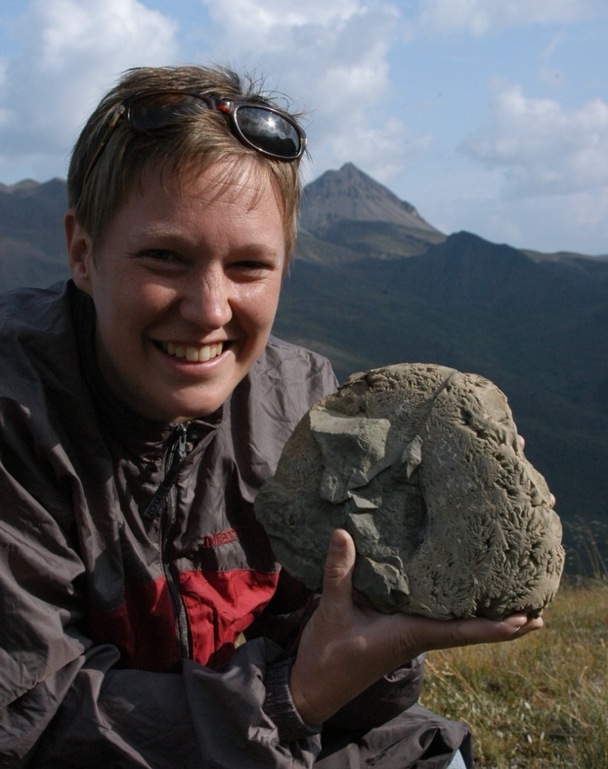
Some members of our group found some very nice specimens for their collections. I was particularly impressed with the find shown at the left.

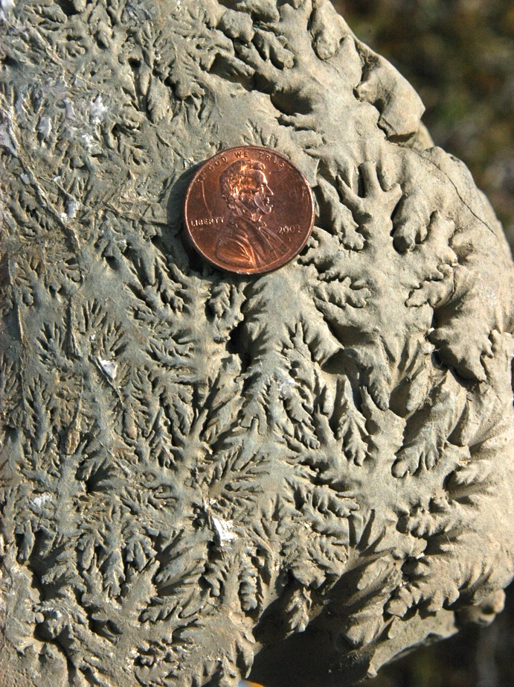
The interesting patterns on the surface of this fossil are called “sutures”. These complex shapes mark the locations where internal chambers of the ammonite intersect the shell walls. The outer shell of the specimen shown in the photo had been eroded away, thus exposing the suture lines.

As ammonites grow and enlarge their shells, new internal chambers are added, such that many internal sutures develop over an ammonite’s lifetime. The shapes of the sutures are unique to a specific species of ammonite and can be used for identification. Below is a close-up of the partially eroded sutures on this fossil. Very unique!

This adventure was fascinating from start to finish. We departed with our fossil treasures, sore muscles, smiles on our faces, and wonderful memories.

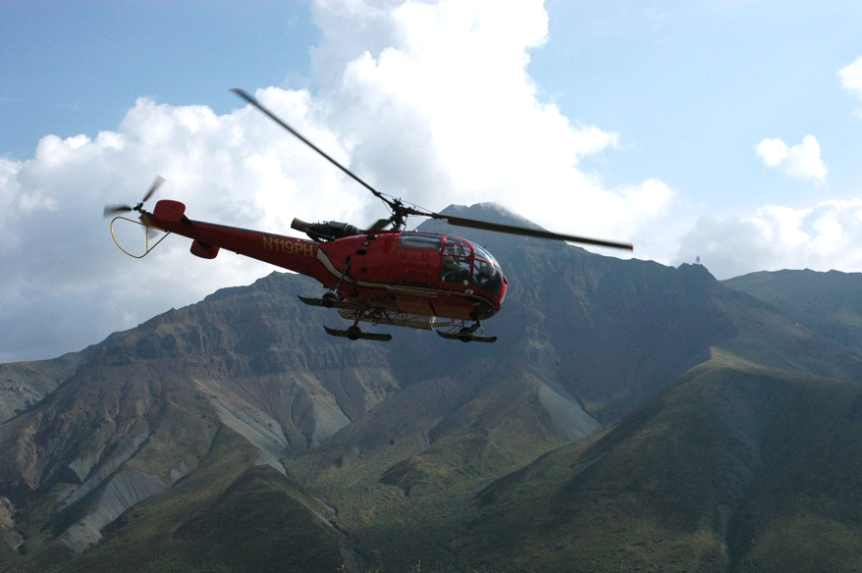

Jim Miller
Jim Miller is a long-time member of Maplewood Rock & Gem Club. He is a retired geologist and holds a Bachelor of Science degree in geological engineering, as well as a Master of Science degree in environmental geology. Jim has loved rocks, fossils, crystals and the natural world since grade school. He enjoys rock tumbling and is an accomplished flintknapper. In 2006 Jim wrote and published a CD book on the types of stone used for knapping arrowheads and stone knives. He enjoys technical writing and has had several of his articles published in Rock & Gem magazine.

Who doesn’t like free?


In 2026 Washington public lands agencies have chosen the following days when you don’t need a Discover Pass to park at
- state parks
- Washington State Department of Natural Resouces land
- Washington Department of Fish and Wildlife land

A Discover Pass costs $45 for a year of parking on state land listed above. The pass covers two vehicles.

The Discover Pass funds significantly help the state agencies provide
- recreation opportunities
- conservation of forests and seashores
- clean bathrooms
- trail maintenance

The free days in 2026 are
Monday, March 9 – Billy Frank Jr.’s Birthday
Thursday, March 19 – State Parks 113th Birthday
Wednesday, April 22 – Earth Day
Saturday – Sunday, June 6-7 – Free Fishing Weekend
Friday, June 19 – Juneteenth
Sunday, Aug. 9 – Smokey Bear’s Birthday
Saturday, Sept. 26 – National Public Lands Day
Saturday, Oct. 10 – World Mental Health Day
Wednesday, Nov. 11 – Veterans Day
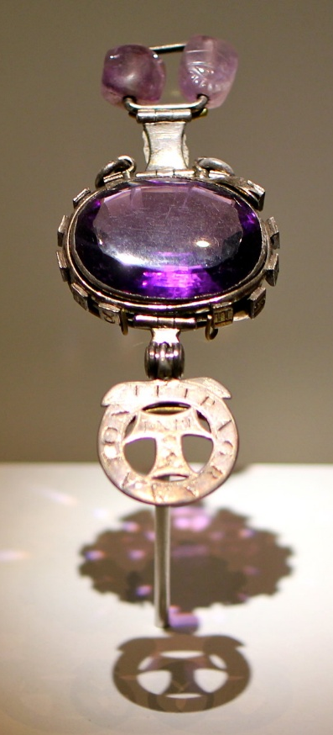
The Cursed Amethyst
Locked away in The Vault of the
Green Zone in the Natural History
Museum in London is the Cursed
Amethyst. The legend behind this
gem is that it was looted from the
Temple of the God Indra in
Cawnpore in 1855 during the Indian
Mutiny. People possessing this
stone were tormented with
disasters, career failures, unfriendly
ghostly spirits, and suicides.

The last owner, Edward Heron-Allen,
secured it into seven boxes and
locked it into a safety deposit box
with instructions that the boxes
should not be opened for 33 years
after his death. His brave daughter waited just a year after his death to donate the cursed gem to the museum.
Photo by Sarah-Rose; License: CC BY-ND 2.0

To rockhounders born in February

Happy Birthday!

Your birthstone is amethyst!

Rock lovers everywhere

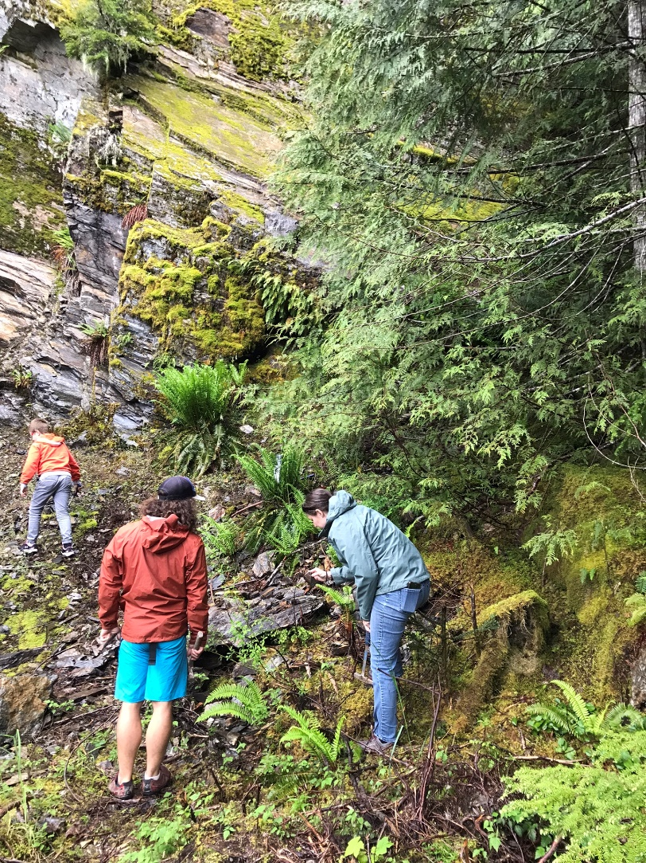
Before you go rockhounding
Rockhounding is fun to do with a group. Join one of the trips listed below and meet other local rockhounders. If you plan to go, please contact the host a week or so ahead to let them know you are coming and to find out if anything has changed.

As you get ready for the trip, we recommend that you go through this checklist:
- Contact the host a week before the trip.
- Plan your driving time so you arrive 30 minutes before the meeting time.
- If needed for parking, get a Discover Pass or America the Beautiful pass, as required.
- Collect your tools and containers for the rocks: https://mineralcouncil.wordpress.com/photos-of-collecting-tools/
- Prepare a first aid kit.
- Plan appropriate clothes, boots, gloves, snacks, and water.
- Gas up your vehicle.
- Review the Rockhound Code of Ethics. It’s important to follow these so that the lands remain open for rockhounding. https://mineralcouncil.wordpress.com/rockhound-code-of-ethics/

Rockhounding Hosts
Here is the contact information for hosts of the rockhounding trips:

Maplewood Club | Don Wilcox | wilcox.don@comcast.net
Marysville Club | Nique Wicks | nwhoppyfrog41@gmail.com  (509) 670-0630
Pow-Wow | Larry Vess | vessel3755@gmail.com  (253) 473-3908
Puyallup Club | Paul Haak | pvhaak@gmail.com  (253) 312-1743
Washington State Mineral Council | Ed Lehman  Nique Wicks (contact information is above) | wsmced2@outlook.com  (425) 334-6282
NW Federation of Mineralogical Societies | Doug True | dtruefossils12@yahoo.com  (406) 670-0506

Trips and shows

Date | Host and Location | Details
Feb. 28 | Marysville  Walker Valley | Search for agate.  Bring digging tools, chisel, bar #3 hammer.
March 22 | Marysville  Skykomish | Search for picture jasper.  Bring a rock hammer, wading boots.
April 18 – 19 | Pow-Wow  Saddle Mountain | Search for petrified wood.  Bring a shovel, small pick, hammer (surface collection).
May 9 | Marysville  Finney Creek | Search for listwanite.  Bring digging tools, hard rock chisel, pry bar, sledgehammer.
May 21 – 25 | NW Federation  Blue Forest, Wyoming | To be announced
May 23 – 24 | Marysville  Kettle Falls, Wild Turkey Mine | Search for fossils and noble serpentine.  Bring a rock hammer and tools for hard rock or surface collection. Fee.
June 13 | Marysville  Saddle Mountain, Diatom Pit | Search for petrified wood and common opal.  Bring a shovel, small pick, rock hammer, buckets with lids (dust).
June 25 – 28 | NW Federation  Tee Pee Canyon Agate, South Dakota | To be announced
July 18 – 19 | Marysville  Lake Wenatchee | Search for garnet and talc.  Bring a shovel screen, container for garnets, hand saw.
Aug. | Maplewood Summer Show | To be announced
Aug. 15 – 16 | Puyallip  Greenwater | Search for agate, jasper, opal  Bring digging tools, chisel, small pry bar, rock hammer.
Sept. 12 – 13 | Pow-Wow  Red Top | Search for agate, jasper, geodes.  Bring digging tools, chisel, small pry bar, rock hammer.
Sept. 19 | Puyallip  Little Naches | Search for lily pad jasper, fossils, thunder eggs.  Bring digging tools, hard rock chisels, pry bar, 3# hammer, rock hammer.
Oct. 11 | Marysville  Walt Bailey | Search for rainbow chert.  Bring hard rock chisels, rock hammers, pry bars.
Nov. 7 | Marysville  Blanchard Hill | Search for Stilpnomelane (dalmation stone).  Bring hard rock flat chisels, hammers, pry bars.
Dec.  5 – 6th | Maplewood Rock and Gem Club | Holiday Show

Grit and oil for sale
The Shop Stewards have grit. When the shop is open you can buy grit or oil. Please email them a day ahead of when you will stop by: shop@maplewoodrockclub.com
Each grit package is $4, and this is what they sell:
1 lb of 60/90 ¾ lb of pre-polish
1 lb of 120/220 ½ lb of polish

Gallon of oil for $20 (Bring your own container.)

Washington State Mineral Council
Our club, along with many other rock and gem clubs in the state, is a member of the Washington State Mineral Council. This organization helps us by
- advocating for access to public lands
- advocating for beneficial land use policies
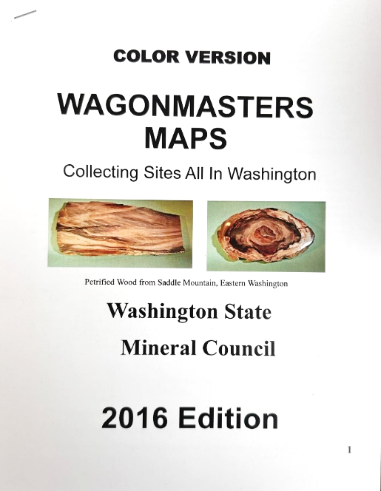
- compiling and sharing maps and other information
- publicizing shows and field trips so members learn about and can participate in events at other clubs

Read their latest Newsletter.

Maps for Rockhounds
The Washington State Mineral Council has put together a 62-page booklet with maps for finding rock hounding sites. You can buy a copy for only $20 at the meeting.

Seattle Regional Gem and Mineral Shows Committee
Our club is a member of a Seattle area organization of rock clubs. Together we share wooden display cases that we use at our shows. These cases are stored in the new shed behind our building. The other member clubs are the North Seattle Lapidary Gem and Mineral Club and the West Seattle Rock Club.

Northwest Federation of Mineralogical Societies
Our club is a member of the Northwest Federation of Mineralogical Societies: http://Northwestfederation.org. We email their newsletter to our members each month.

About Us

Shop Stewards
Rich Osborne
Bruce Samuels
Nathan O’Brien
Dirk Sierag
Scott Higson

Shop@maplewoodrockclub.com

Lapidary Shop
Our lapidary shop is reserved for members who have paid their dues. Inside are five slab saws, three CabKing™ machines for polishing cabochons, and two trim saws.

Sign up for shop time
All shop users must sign up for a time slot at least a day before the session. On their first visit, new shop users will be trained on shop procedures and safety before being able to use any equipment.

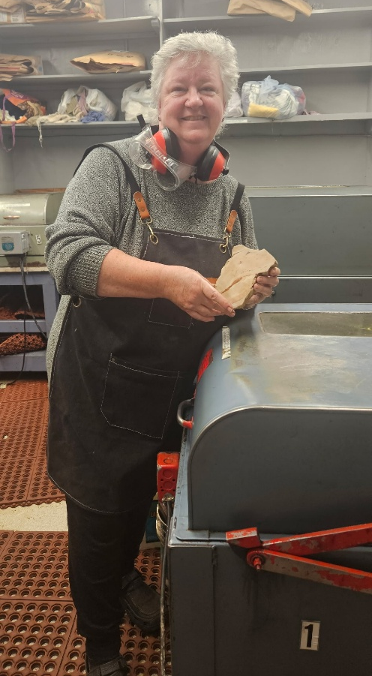
You can sign up for shop time online. The system will send you a confirmation email which you should save until after your session. You will need the email if you need to cancel your reservation. Each Thursday and the 1st and 3rd Wednesdays we have two shop sessions available:
- Session 1: from 3:00 to 5:30 pm
- Session 2: from 5:30 to 8:00 pm

How to cancel
If you sign up for shop time online and later realize you won’t be able to make it, you need to cancel your reservation no later than two days before the session. So, if you are cancelling a Thursday time, you need to cancel by Tuesday at midnight. This enables someone else to sign up. If you do not cancel, you will be charged for the session. To cancel, click the link in the confirmation email you received.

What to bring
You need to bring $10 (cash or check) to pay for the session. Additionally, please bring these:
- Eye protection
- Hearing protectors

Before you leave the shop
The shop stewards are volunteers who generously give 6 hours a week to enable us to use the tools. Before you leave a tool station, please wipe it down and leave it in the same condition as you found it. If you discover a problem with a saw or tool, please let the Shop Steward know.

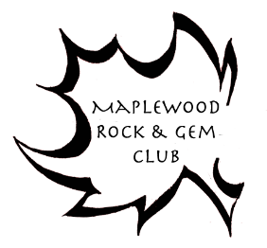
Connect with us
Website: http://www.maplewoodrockclub.com/
Facebook page: Maplewood Rock & Gem Club
Facebook group for members: MRGC Sales and Trades
Email us: info@maplewoodrockclub.com

Address: 8802 196th St SW, Edmonds, Washington 98026

Our Board
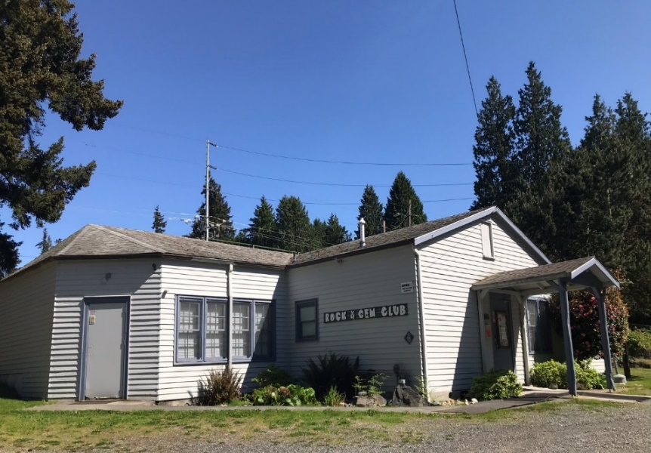
Our club is run entirely by volunteers; and we are grateful for the time, energy, and expertise they give to our community.

President: open
Vice President: open
Treasurer: Lisa Rammell
Secretary: open
Past President: Angela Vitense
Members at large: Paul Newby, Mark Tomas, and two openings.

Image licenses
We use abbreviations in the license attributions. Here are the definitions.
CC: Creative Commons license
BY: attribute the author, link to the license, and indicate if changes were made.
SA: share alike - If you publish the image, you must use the same license.
ND: no derivatives - You may not alter the image.
NC: non-commercial use - You may not use the image for commercial use.
3.0 or other number: version of the license
News to share?
Did you go rockhounding? Have you acquired a beautiful new specimen? Contact Nancy Samuels, the Editor at MRGC@nancysamuels.com.
This issue
Maplewood Rock and Gem Club News

Volume 02
Publication year: 75

